User Guide:-

Imported Modules

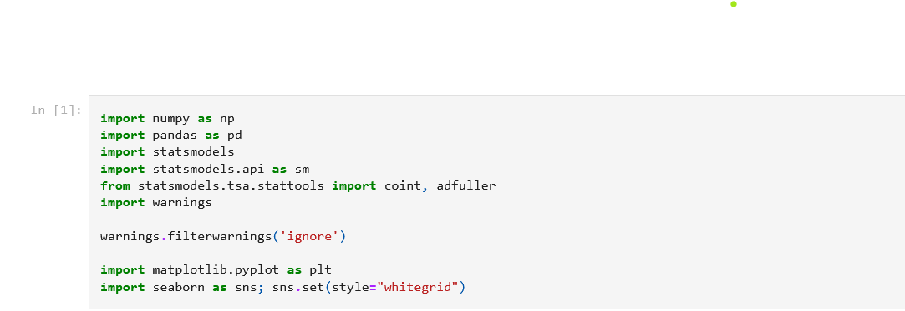

Use gaussian distribution ,empirical rule dictates that trade lies between x+sigma and x-sigma

<https://www.investopedia.com/terms/e/empirical-rule.asp> (took it as reference)

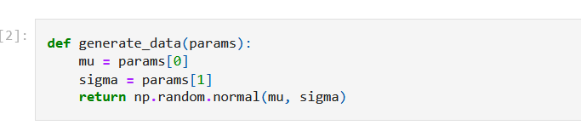

Took two assumptions stationary and non stationary

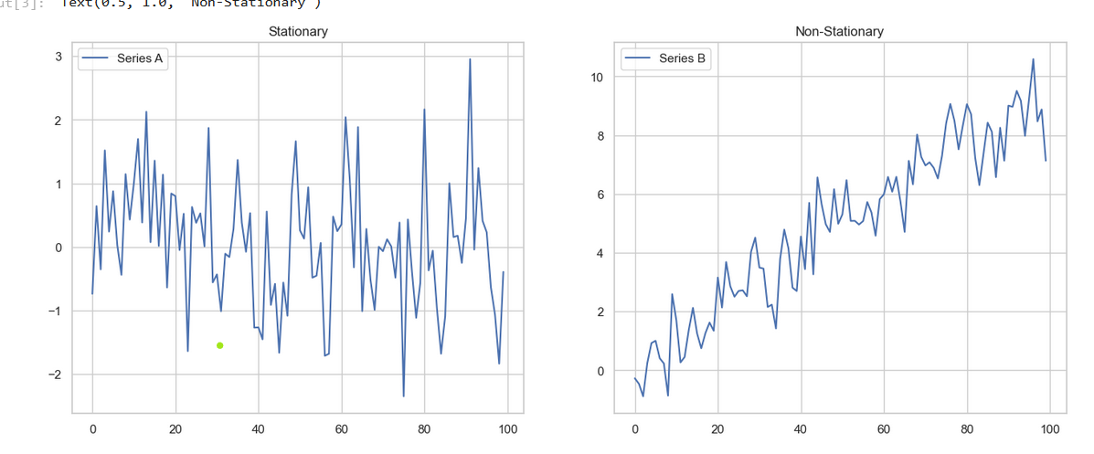

Drawn mean line

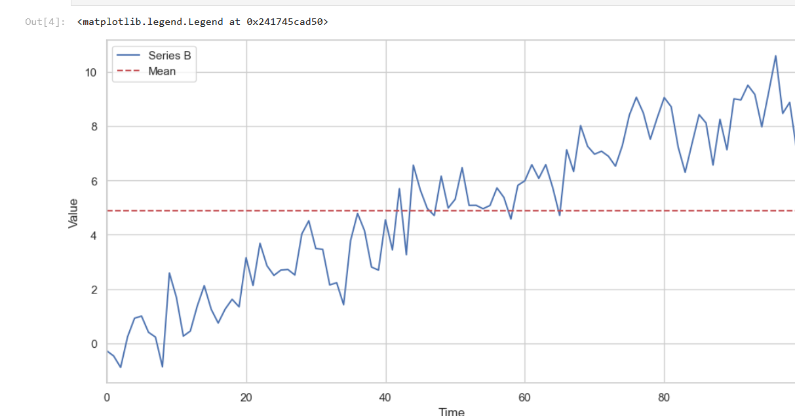

#### For stationary testing used Augmented Dickey Fuller (<https://en.wikipedia.org/wiki/Augmented_Dickey%E2%80%93Fuller_test>)

#### 

#### Hence proved

#### 

It generates and plots two correlated stock price series, where one series (Y) is derived from the other (X) by adding a constant shift and random noise.

Similarly for next step keep untitled 1 as reference

Generate and Plot Correlated Price Series:

* Series X and Y are generated such that Y is a noisy version of X.
* The spread between X and Y is plotted, showing its mean.

Cointegration Test:

* The cointegration test is applied to X and Y, resulting in a low p-value indicating strong cointegration.

Generate Diverging Price Series:

* Series X_diverging and Y_diverging are generated with different means.
* The correlation and cointegration tests show high correlation but no cointegration

Create Two Synthetic Series with Structured Variation:

* Y2 is a random series, and Y3 is Y2 with periodic shifts in mean.
* Plot and analyze their correlation and cointegration.

Download Stock Data:

* Stock prices for selected tickers are downloaded using yfinance.

Find Cointegrated Pairs:

* Cointegration tests are applied to all pairs of stock price series.
* Significant pairs are identified and visualized using a heatmap.

Analyze a Cointegrated Pair:

* The spread and price ratio between ADBE and MSFT are analyzed.
* Z-score of the price ratio is plotted to identify potential trading signals.

Simple Trading Strategy:

* A function trade simulates a trading strategy based on the z-score of the price ratio.
* The strategy is backtested on the training and test datasets.
* Optimal window lengths for moving averages are determined.

Evaluate Trading Strategy:

* The performance of the trading strategy is evaluated and visualized.
* Best window lengths for training and test periods are identified and compared.